A Level Biology Bridging work

Exam board specification: <https://www.aqa.org.uk/subjects/science/as-and-alevel/biology-7401-7402>

Suggested reading list, websites, pod casts, films etc.

* 15% of our A level examinations questions are based on 12 required practicals that you will need to complete over the 2 years you will study Biology. Please make sure you brush up on your practical or some schools call them ‘how science works’ skills
  1. <https://www.physicsandmathstutor.com/biology-revision/gcse-aqa/practical-skills>
  2. <https://www.youtube.com/watch?v=SX6mow1AExI&list=PLAd0MSIZBSsHv1pioWRdg-pZCWTo84cdP>
* Maths is also a really important part of our A level course – just like GCSE it makes up 10% of all our exam paper questions, so again please make sure you brush up on your GCSE maths skills ready to start in September <https://www.youtube.com/watch?v=aaoq1HPvI6E>
* If you have got all this covered, try a Future learn course on an aspect of Biology that interests you – you have time and it would be great for a university application #cvbuilding <https://www.futurelearn.com>
* Complete, mark and correct the following past papers: AQA Biology GCSE (Higher) June 2018 Paper 1 AQA Biology GCSE (Higher) June 2018 Paper 2. You can find the papers and mark schemes on the AQA website: <https://www.aqa.org.uk/find-past-papers-and-mark-schemes>
* In A Level Biology you learn about the structure of the cell in more detail. Have a go at making a model cell to help you get to grips with the new organelles you will learn
* 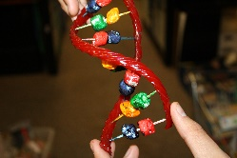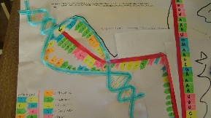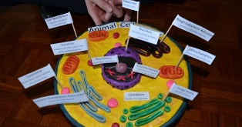Make a model to show the structure of DNA and the process of transcription and translation. <https://studyrocket.co.uk/revision/a-level-biology-aqa/genetic-information-variation/dna-the-genetic-code>