**PHYSICS SUMMER PROJECT 2020**

**PART 1**

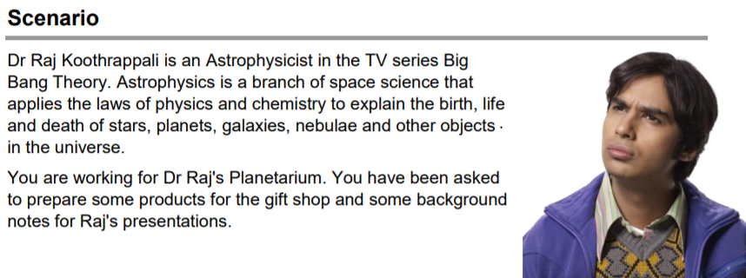



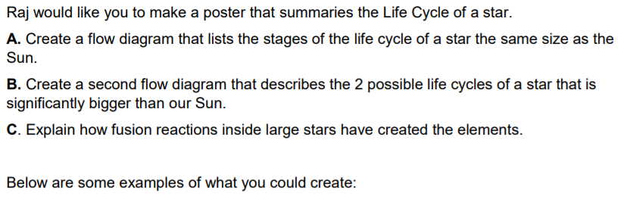

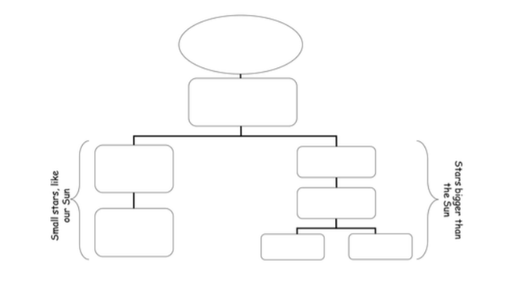

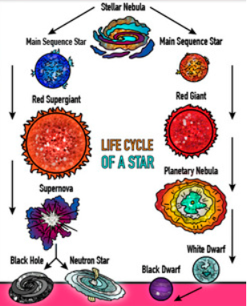 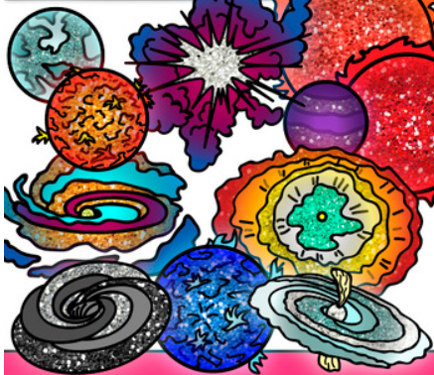



**Astrophysics Timeline Task**

**Make a flowchart of the development of key theories in astrophysics. Try to include how each astronomer builds upon the theories that came before them.**

Use internet research, your textbooks, revision guides and YouTube to create a flowchart of key theories in astrophysics. I suggest that you keep to these headings, but you are welcome to branch out from them. You can also add headings if you feel that there are important things I have left out.

**Copernicus**

**Kepler**

**Galileo**

**Newton**

**Moon’s Acceleration**

**Mass of the Moon**

**Einstein’s Theory of Gravity**

**Hubble and the Expanding Universe**

**Stellar Classification and Evolution – Wein’s Law / Stefan’s Law and Hertzsprung-Russel Diagrams**

**Swarzchild Radius**

**Neutron Stars**

**Black Holes**

**Hubble Telescope and the Deep Field Image**

**Dark Matter and Dark Energy**

**PART 2**

**Rocketry Task**

Use this link <https://spacedge.academy/course/view.php?id=51> to do this course, which provides an overall overview of rocket and spacecraft design, important aspects of rocketry and space exploration. This is a course designed for learning purposes and for a general context that will hopefully help you design a viable and meaningful experiment.

The course provides a wide array of links and information but you can also do internet research, textbooks and YouTube.

**PART 3**

This activity will assist you in getting better prepared to study A Level Physics.

Once you have completed ‘Part 3’, you can self-assess to check your answers and start identifying the areas for improvement.

|  |  |
| --- | --- |
| AS Physics | Task 1 – Rearranging Equations |
| Skills |

*Rearrange each equation into the subject shown in the middle column.*

|  |  |  |
| --- | --- | --- |
| **Equation** |  | **Rearrange Equation** |
|  | *R* |  |
|  | t |  |
|  | *A* |  |
|  | *r* |  |
|  | *u* |  |

|  |  |  |
| --- | --- | --- |
| **Equation** |  | **Rearrange Equation** |
|  | ***f*** |  |
|  | g |  |
|  | *F* |  |
|  | *u* |  |
|  | *m* |  |

|  |  |
| --- | --- |
| AS Physics | Task 2 – Variables |
| Skills |

A variable is a quantity that takes place in an experiment. There are three types of variables:

Independent variable – *this is the quantity that you* ***change***

Dependent variable – *this is the quantity that you* ***measure***

Control variable – *this is a quantity that you* ***keep the same*** *so that it does not affect the results*

You can only have one independent variable and one dependent variable, but the more control variables you have the more accurate your results will be.

Further to these, you can also split the independent variable category – this can be continuous or discrete.

A continuous variable can take *any* numerical value, including decimals. You will construct line graphs for continuous variables.

A discrete variable can only take *specific* values or labels (eg. integers or categories). You will construct bar charts for discrete variables.

*For each case study below, state the independent variable, dependent variable, and any control variables described.* ***Add further control variables****, and state what type the independent variable is and what type of graph you will present the results with (if required).*

Case study 1 – *Measuring the effect of gravity*

The aim of this experiment is to find out how fast objects of different masses take to fall from height. To conduct this experiment we used a number of spheres of the same diameter, which had different masses. Each sphere had its mass measured on electronic scales, before being dropped from a marker exactly 2.000 m from the floor. The time the sphere took to drop was timed on a stopwatch, and repeated 3 times for each sphere to gain an average time.

Independent variable:

Dependent variable:

Control variables:

Type of independent variable:

Graph:

Case study 2 – *The number of children involved in different after school activities.*

The aim of this study is to discover which activities are most popular so the correct resources can be supplied to the correct member of staff. On a certain day after school the number of children were recorded for the different activities they took.

Independent variable: ­­­­­­­­­

Dependent variable:

Control variables:

Type of independent variable:

Graph:

Case study 3 – *How far does the spring stretch?*

The aim of this experiment is to find how far different masses stretch a spring. A spring was hung from a clamp stand, and its length end to end measured. A 10g mass was then added and the length of the spring measured and recorded. This was repeated adding 10g between 0g and 100g.

Independent variable:

Dependent variable:

Control variables:

Type of independent variable:

Graph:

Case study 4 - *What is the best design for a turbine?*

A wind turbine is connected to a voltmeter and is placed 1.0 m from a desk fan. The potential difference produced for different number of blades attached to the turbine is measured. The aim is to see what design produces the largest potential difference.

Independent variable:

Dependent variable:

Control variables:

Type of independent variable:

Graph:

|  |  |
| --- | --- |
| AS Physics | **Tasks 1 and 2 Solutions** |
| Skills |

**Task 1**

R = V/I t = Q/I A = ρL/A r = (ε-V)/I

u = 2s/t - v f=( Φ + EK)/h g= EP,/ mh F= 2E/e

u= √( v2-2as) m = T2 k/ 4π2

**Task 2**

Case study 1

IV Mass of sphere DV time to fall a set distance CV drop distance, diameter of sphere

IV continuous graph - line graph

Case Study 2

IV types of activities DV number of children CV time of day and day of the week

IV categoric / discrete graph bar chart

Case study 3

IV Value of mass (g) DV length of spring CV same spring, spring stationary when measured

IV continuous graph line

Case study 4

IV number of blades DV output potential difference

CV same dist from fan, constant fan output, same blade design

IV discrete graph bar chart